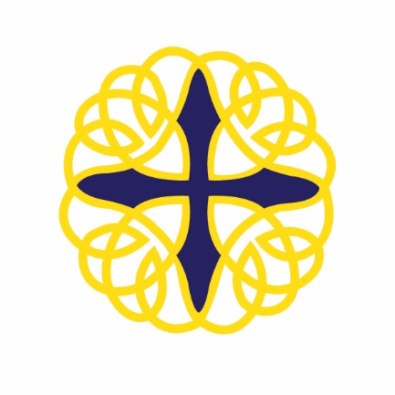
Coláiste Naomh Feichín
Corr na Móna
Co. na Gaillimhe

Fón: 094 9548006 Facs: 094 9548048
Email: eolas.feichin@gretb.ie

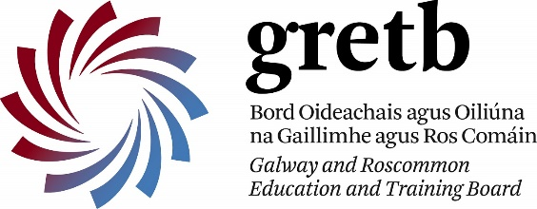

3 Nollag, 2021
A chairde,
Beatha agus Sláinte.
Mar is eol daoibh is scoil Gaeltachta muid agus tá scoil s’againne ag tabhairt faoi Aitheantas a fháil mar Scoil Gaeltachta ón bhliain 2017. Is mian linn an Ghaeilge a leathnú i measc ár ndaltaí scoile, foireann na scoile, pobal na scoile agus timpeallacht Dhúiche Sheoigheach ach go háirithe.
Tá daltaí na hIdirbhliana ag tabhairt faoi sraitheanna de fhíseáin a chruthú chun feabhas a chur ar ár gcuid Gaeilge. “Gaeilge le Chéile” ainm na físeáin. Beidh ceacht seachtainiúil ann go ceann 8 seachtaine. Bígí leo agus Bígí linn. Is féidir teacht ar an gcéad ceacht ar suíomh na scoile. Brú ar Gaeilge le Chéile ar bharr na leathanaigh.
As you are all well aware, our school is a Gaeltacht school and we are working towards achieving recognition as a Gaeltacht school since 2017. We endeavor to promote Gaeilge among our students, our staff, our school community and Joyce Country.
Our Transition Year group are embarking on creating a series of short grammatical lessons in Irish. Please take the time to view and enjoy the first lesson just published on our website. Bígí leo agus Bígí linn ar Ghaeilge le Chéile.
Mar a deir an seanfhocal, “Beatha teanga í a labhairt”.

Le meas oraibh,

Gearóidín Ní Chonghaile

