Coláiste Naomh Feichín
Corr na Móna
Co. na Gaillimhe

Fón: 094 9548006 Facs: 094 9548048
Email: eolas.feichin@gretb.ie

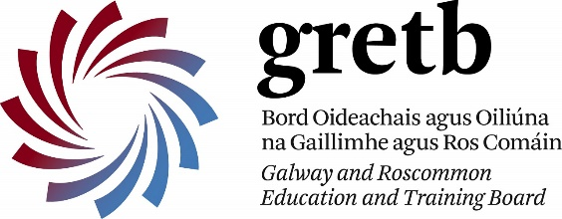

22 d’Aibreáin, 2021
Scrúdú na hArdteistiméireachta 2021 – Eolas Tábhachtach
A chairde,

Beatha agus Sláinte. Beidh an Tairseach Féinseirbhíse Iarrthóra ar oscailt arís Dé Máirt, an 27ú lá d’Aibreáin 2021 go dtí Dé hAoine an 30ú lá d’Aibreáin 2021. Beidh iarrthóirí athbhreithniú in ann a dhéanamh ar na roghanna atá déanta do gach ábhair agus iad a thabhairt chun críche.
Cuirfidh Coimisiúin na Scrúduithe Stáit treoir breise ar fáil d’iarrthóirí roimhré.
- Is é athoscailt an Tairsí Iarrthóra an deis deireadh a bhéas ag iarrthóirí lena chur in iúl an leibhéil ag a mbronnfar na Gráid Chreidiúnaithe.
- Nuair a dhúnann an Thairseach, ní bheidh na hiarrthóirí ná na scoileanna in ann na leibhéil seo a athrú.
- Is gá d’iarrthóirí breathnú ar rogha leibhéil i gach ábhair go h-an-cúramach.
- Beidh cead ag iarrthóirí a roghnaíonn na scrúduithe a dhéanamh an leibhéil a athrú ar lá an scrúdú.
The Candidate Self-Service Portal for Leaving Certificate will re-open on Tuesday, 27th April until Friday 30th April to enable candidates to review and finalise the choices they have made for each subject. The following should be noted:
- The re-opening of the Candidate Portal is the final opportunity for candidates to indicate the level at which Accredited Grades will be awarded.
- After the Portal closes, it will no longer be possible for either candidates or schools to change these levels, as it will be too near to the process that applies to Accredited Grades.
- Candidates do need to consider their choice of level in each subject very carefully.
- Candidates who choose to sit the examinations will be allowed to change level on the day of the examination.

Le meas ort,

Gearóidín Ní Chonghaile
Príomhoide

