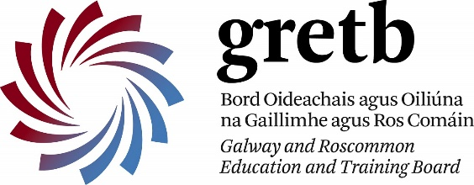
Coláiste Naomh Feichín
Corr na Móna
Co. na Gaillimhe

Fón: 094 9548006 Facs: 094 9548048
Email: eolas.feichin@gretb.ie

12ú d’Aibreáin, 2019
Chuig: Tuismitheoirí / Parents – 2019/’20 Bliain 1
A Chairde,
Tá Lá Aclaíochta á eagrú againn ar an Aoine, 18ú Bealtaine do na scoláirí a bheidh ag teacht isteach i mBliain 1 don scoilbhliain 2019/’20. Beidh na scoláirí atá i mBliain 1 faoi láthair ag glacadh páirt in imeachtaí leo ar feadh an lae agus tabharfaidh sé seo deis dóibh aithne mhaith a chur orthu siúd agus ar na scoláirí a bheidh sa rang leo an bhliain seo chugainn.

On Friday, 18th May, we are planning an Activity Day for the students who will be in 1st year in the next school-year (2019/’20). The present Bliain 1 will participate with them on the day and this will give the new students an opportunity to get to know the present Bliain 1 and their next year’s classmates. The arrangements are dependent on weather – fingers crossed for a fine sunny day!
Can you please organize to get the student to the Coláiste by 9.15am on Friday, 18th May, and collect him/her at the Coláiste by 1.20pm.

The activities taking place on the day will include baking, woodwork and various sports and also some time to get to know each other which is one of the most important purposes of the day. Students should be suitably dressed and bring with them a change of clothing including footwear. Some refreshments will be provided but students should also bring some lunch and a drink. This is intended to be a fun day for all.

It will not be necessary for students to participate in any event that they are uncomfortable with. Students will be well supervised during their time with us. We look forward to meeting the students on Friday morning, 18th May and yourself on the date below.
Please find enclosed an extra admission form requesting additional information regarding your child’s needs in school. Please return to me on the evening of the 9th May.
Dáta Tábhachtach / Important Date
Déardaoin / Thursday, 09/05/’19 – 6.30 i.n.
PARENTS: You are invited to attend a meeting of all parents of incoming 1st year students which be held at the Coláiste at 6.30 p.m. on Thursday, 9th May.
A representative of the company Wriggle will attend and give all details of the new Tablet which will be offered to new students.
Other school matters will be discussed.
If you are able to attend, please do so. Bí ann, le do thoil
Beidh muid ag súil go mór le bualadh le na scoláirí agus leat féin ar an dáta thíos.

Le meas,

__________________________________
Gearóidín Ní Chonghaile
Príomhoide

