Coláiste Naomh Feichín
Corr na Móna
Co. na Gaillimhe

Fón: 094 9548006 Facs: 094 9548048
Email: eolas.feichin@gretb.ie

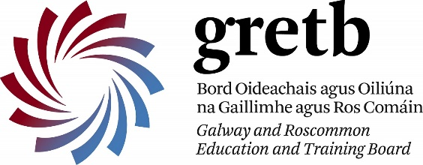

10/05/2018

Chuig: Tuismitheoirí Bliain 5

TURAS Bliain 5

Beidh daltaí na cuigiú bliana ag dul ar thuras eachtraíochta Dé Luain an 28ú lá de Bhealtaine. Beidh siad ag dul go dtí Pallas Karting i Tynagh, Co. na Gaillimhe. Beidh múinteoirí leo. Fágfaidh an bus an Choláiste ag 8.45r.n. agus beidh siad ar ais ag an gColáiste ar a 3.50i.n. Beidh ár ndaltaí ag glacadh páirt sna himeachtaí seo a leanas: Paintballing agus Karting
Beidh éadaí reatha uatha ar an lá. Daltaí go bhfuil fadhbanna sláinte ar nós asma, ba cheart go mbeadh gach cóir leighis leo ar an lá. Tá costas €40 ar lá. Beidh costas an bus á chlúdach mar gur éirí le Bliain 5 duais labhairt na Gaeilge a bhuachaint. Caithfear an t-airgead seo a bheith istigh roimh Dé Máirt an 21ú lá de Bhealtaine. Bíodh an t-airgead i gclúdach litreach le hainm an dalta air. Cuir sa Bhosca Buí an clúdach.

Please note that 5th year students will have a days’ activities in Pallas Karting on Monday 28th May. Students will be accompanied by teachers. The bus will leave the Coláiste at 8.45am and will return at approximately 3.50pm. Students will participate in the above activities. Students must bring sufficient lunch and drinks. Please ensure that your son/daughter has leisurewear. Students with medical issues must ensure that they have all necessary medications with them on the day, e.g. inhaler. If you are happy for your child to participate in the above trip, please note that the costs are as follows: €40 for the day. 5th year students have won the prize to cover their cost of the bus trip as part of the school campaign of the promotion of the Irish language. The payment can be placed in an envelope in the Yellow Box with the note below before Tuesday, 21st May.

Gearóidín Ní Chonghaile
---------------------------------------------------Gearr anseo / Cut here---------------------------------------------------------
Turas go Tynagh
Tugaim cead do / I permit __________________________________________ Bliain __________ taisteal go Pallas Karting ar an Luain, 28/05/’18 / travel to Pallas Karting on Monday, 28/05/’18.

Síniú Tuismitheoirí / Signature of Parent : _________________________________ Enclosed €40

